**Project Design Phase -1**

**Solution Architecture**

|  |  |
| --- | --- |
| **Date** | 03/10/2022 |
| **Team ID** | PNT2022TMID49911 |
| **Project name** | Personal assistant for seniors who are self -reliant |

**Architecture :**

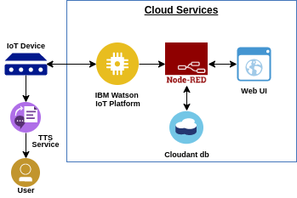

**Problem :**

Some people find it difficult to learn new apps in this ever- expanding digital environment, and people nowadays tend to forget things more easily, such as taking their prescriptions, people need a way to remember to take their prescriptions without having to learn how to use sophisticated programs.

**Main goal:**

Create a basic call application easy to use application, so that users don’t forget their medicine schedules , can easily discover pharmacies and clinics near them, and can be directed through the application by their loved one easily.

**Solution:**

The category of patient Involve all human beings-teachers, students, businessmen, housewives, children and also all of us have a busy hectic schedule. Today’s life is full of responsibilities and stress. so people are prone to diseases of different types and it is our duty to make ourselves stay fit and healthy. If the patient stays at home then he or she might get someone to look after him/her but when one is not at home, is out of the city or state away from home then it is hard for the family members to call them and remind them their dosage timings every time. In this system is fully call based application ,we will create a ten digit number with emergency code. Through this number we will send call take medicine at respective time, at t the same time the LED and Buzzer ON automatically the patient take medicine in this medicine box the LED and Buzzer OFF automatically. In this system the patient can take the medicine at the respective time without caretakers. So the caretaker save our time.